1: screenshot of all instruction menu single linked list

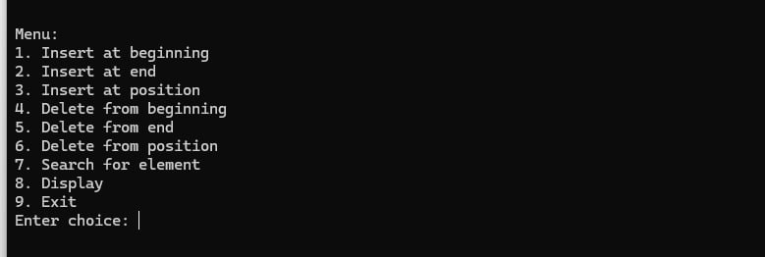

* 1. screenshot of insert at the beginning from menu number one

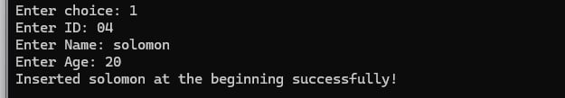

* 1. screenshot of insert at the end from menu number two

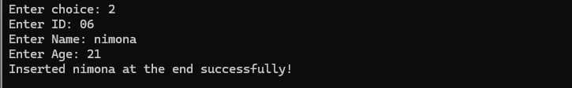

* 1. screenshot of insert at the position from menu number three

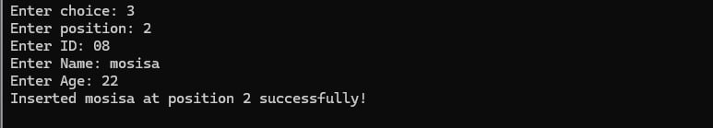

1.4 screenshot of delete from beginning ,from menu number four



* 1. screenshot of delete from end ,from menu number five



* 1. screenshot of delete from position, from menu number six

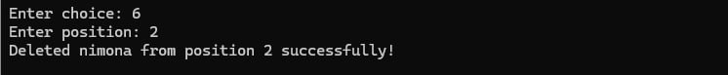

* 1. screenshot of search for element from menu number seven

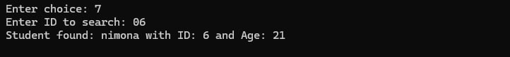

* 1. screenshot of display proper handling of edge cases, such as an empty list, from menu number eight



* 1. screenshot of display all from menu number 1,2,and 3



1. : screenshot of all instruction menu double linked list



* 1. screenshot of insert at the beginning from menu number one

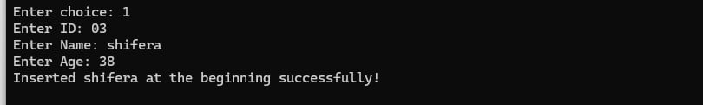

* 1. screenshot of insert at the end from menu number two

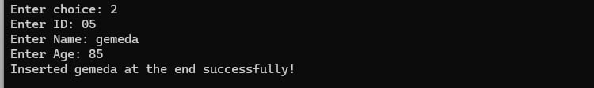

* 1. screenshot of insert at the position from menu number three

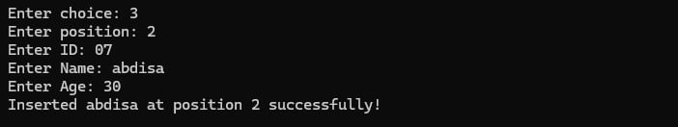

* 1. screenshot of delete at beginning from menu number four



* 1. screenshot of delete at end from menu number five



* 1. screenshot of delete from position ,from menu number six

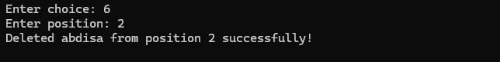

* 1. screenshot of search element, from menu number seven



* 1. screenshot of display all menu number 1,2 and3



1. : screenshot of all instruction menu circular singly linked list



* 1. screenshot of insert at beginning from menu number one

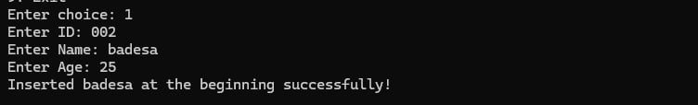

* 1. screenshot of insert at end from menu number two

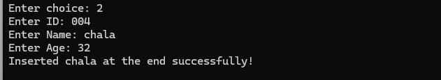

* 1. screenshot of insert at position from menu number three

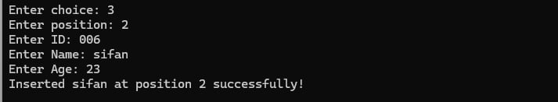

* 1. screenshot of delete from beginning , from menu number four



* 1. screenshot of delete from the end ,from menu number five

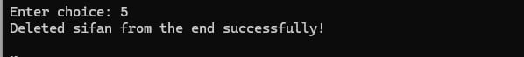

* 1. screenshot of delete from position, from menu number six

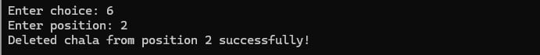

* 1. screenshot of search element , from menu number seven

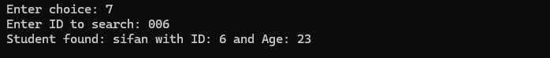

* 1. screenshot of display all menu number 1,2 and 3



1. : screenshot of all instruction menu circular double linked list



* 1. screenshot of insert at beginning , from menu number one

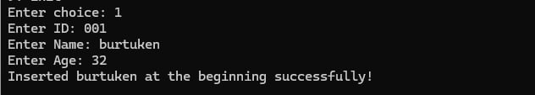

* 1. screenshot of insert at end , from menu number two

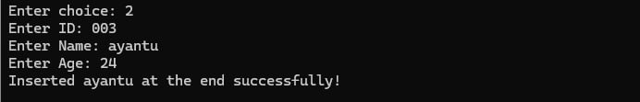

* 1. screenshot of insert at position, from menu number three

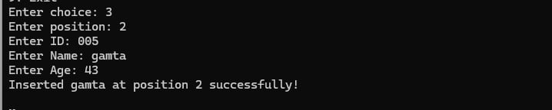

* 1. screenshot of delete from beginning , from menu number four



* 1. screenshot of delete from end , from menu number five



* 1. screenshot of delete from position, from menu number six

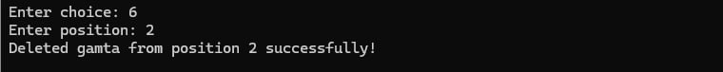

* 1. screenshot of search element , from menu number seven

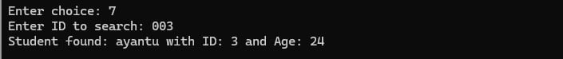

* 1. screenshot of display all menu number 1,2,and 3.

